
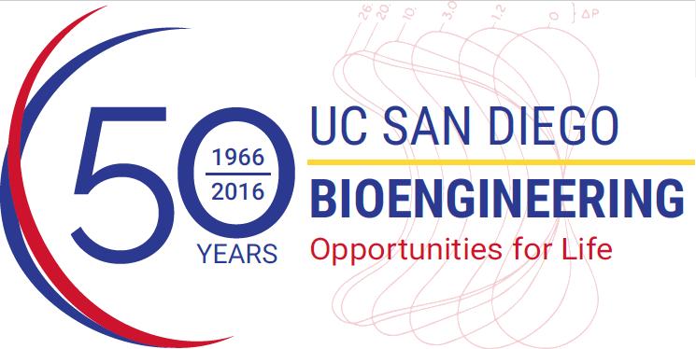
BENG281 Seminar

Heather Christofk
Assistant Professor
Department of Molecular and Medical Pharmacology
University of California, Los Angeles
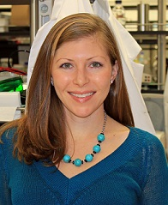
Use of Viruses to Study Cancer Metabolism

Abstract: Viruses are powerful tools to study cancer metabolism. They trigger major metabolic changes in host cells to meet the bioenergetic and biosynthetic demands of virus infection - changes similar to the enhanced glycolysis and anabolic metabolism widely observed in cancer cells. However, unlike cancer cells, viruses undergo intense selection for efficiency, and rapidly and robustly reprogram host cell metabolism through activation of specific key flux-altering nodes, rather than whole metabolic pathway gene sets. We recently reported that adenovirus infection increases host cell anabolic glucose metabolism via MYC activation of specific metabolic target genes, only a subset of those turned on by MYC in many cancers. We are now investigating how adenovirus-induced MYC activation leads to selective transcription of target genes. Additionally, we have generated a list of the specific metabolic genes altered by adenovirus infection and are examining their role in anabolic metabolism, virus replication, and cancer proliferation. Because viruses are so efficient at reprogramming host cell metabolism towards increased anabolism, they represent a powerful tool to identify the most important metabolic enzymes for anabolic metabolism, and potentially the most promising cancer metabolism drug targets.

Biography: Heather Christofk is an assistant professor in the Department of Molecular and Medical Pharmacology at UCLA and an affiliate of the Jonsson Comprehensive Cancer Center and the Broad Stem Cell Research Center at UCLA. Her research focuses on the regulation and role of metabolic switches in cellular transformation, virus infection, and differentiation. By elucidating regulatory mechanisms for metabolic switches in normal and disease states, she hopes to identify diagnostic and treatment strategies for cancer patients. Dr. Christofk received a bachelor’s degree in Molecular, Cell, and Developmental Biology from UCLA in 2001, and a doctorate in Cell and Developmental Biology from Harvard University in 2007 under the mentorship of Dr. Lewis Cantley. After a postdoctoral fellowship with Dr. Frank McCormick at UCSF, she joined the faculty at UCLA in 2008. Dr. Christofk is a Searle Scholar and has been awarded a Damon Runyon-Rachleff Innovation Award and a NIH Director’s New Innovator Award.

